**IBM NALAIYATHIRAN**

**IoT Based Safety Gadget For Child Safety Monitoring & Notiﬁcation**

**Project Report**

**TEAM ID:PNT2022TMID47136**

**Submitted By**

Team Leader:

**SUDHARSHINI V (822419104046)**

Team Members:

|  |  |
| --- | --- |
| **NISHANTHINI K** | **(822419104029)** |
| **SHARMILA R** | **(822419104039)** |
| **THARANI K** | **(822419104301)** |
|  |  |

Table Of Contents

1. **INTRODUCTION**
   1. Project Overview
   2. Purpose
2. **LITERATURE SURVEY**
   1. Existing problem
   2. References
   3. Problem Statement Definition
3. **IDEATION & PROPOSED SOLUTION**
   1. Empathy Map Canvas
   2. Ideation & Brainstorming
   3. Proposed Solution
   4. Problem Solution fit
4. **REQUIREMENT ANALYSIS**
   1. Functional requirement
   2. Non-Functional requirements
5. **PROJECT DESIGN**
   1. Data Flow Diagrams
   2. Solution & Technical Architecture
   3. User Stories
6. **PROJECT PLANNING & SCHEDULING**
   1. Sprint Planning & Estimation
   2. Sprint Delivery Schedule
   3. Reports from JIRA
7. **CODING & SOLUTIONING (Explain the features added in the project along with code)**
   1. Feature 1
   2. Feature 2
   3. Database Schema (if Applicable)
8. **TESTING**
   1. Test Cases
   2. User Acceptance Testing
9. **RESULTS**
   1. Performance Metrics
10. **ADVANTAGES & DISADVANTAGES**
11. **CONCLUSION**
12. **FUTURE SCOPE**
13. **APPENDIX**

Source Code

GitHub & Project Demo Link

# INTRODUCTION

**1.1 Project Overview**

Internet of Things (IoT) plays a major role in every day-to-day life. The major difference between IoT and embedded system is that a dedicated protocol/software is embedded in the chip in case of embedded system, whereas, IoT devices are smart devices, which are able to take decisions by sensing the environment around the device. The development of sensors technology, availability of internet connected devices; data analysis algorithms make IoT devices to act smart in emergency situations without human interventions.

So, IoT devices are applied in different fields such as agriculture, medical, industrial, security and communication applications. IoT systems are useful within a system to do deeper automation, analysis, and integration. IoT contributes to technology by advances in software, hardware and modern tools.

It even uses existing and upcoming technology in the fields of sensing, networking and robotics. IoT brings global changes by its advanced elements in the social, economic, and political impact of the users.

Child tracker helps the parents in continuously monitoring the child’s location. They can simply

leave their children in school or parks and create a geofence around the particular location. By continuously checking the child’s location notifications will be generated if the child crosses the geofence.

Notifications will be sent according to the child’s location to their parents or caretakers. The entire location data will be stored in the database.

# 1.2. Purpose

The main purpose of this device is “to provide safety to the child by allowing the parent to locate the child and view their surroundings”. This device can be used to monitor the child’s location through geofence. The gadget allows us the guardian or parents to track their child’s whereabouts, ensuring they’re safe and within range. With the use of the parental control app, we have the ability to approve all watch contacts and block unknown numbers keeping your young one away from strangers. This system requires web UI, iot Watson platform, ibm cloud, node-red application and etc...

The child safety wearable system acts as a “smart device”. Child’s surroundings can be located with the help of accurate and precise real-time location. Surrounding environment temperature, SOS light along with Distress buzzers are provided in this system. It assists parents to monitor their children remotely. In case situations happen, notifications will be sent to parents so that actions can be taken. Through this, child safety can be ensured and crime rate will be reduced.

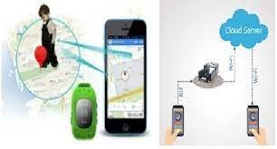The internet of things (IOT) refers to the set of devices and system that stay interconnected with real-world sensor and to the internet. During years’ Child safety is under threat and it is very important to provide a technology-based solution which will help them under panic situations and monitor them using a smart gadget. The proposed system is equipped with GSM and GPS modules for sending and receiving call and SMS between safety gadget and parental phone, the proposed system also consists of Wi-Fi module used to implement IoT and send all the monitoring parameters to the cloud for android app monitoring on parental phone.

Android application can be used to track the current location of safety gadget using its location coordinates on parental phone android app and also through SMS request from parent phone to safety gadget. Panic alert system is used during panic situations and automatic SMS alert and phone call is triggered from safety gadget to the parental phone seeking for help and also monitored for plug and

unplug from hand, as soon the gadget is unplugged from hand a SMS is triggered to parental phone and the alert parameter is also updated to the cloud.

# LITERATURE SURVEY

* 1. **Existing problem**

Most kids who are reported missing have run away or there has been a misunderstanding with their parents about where they were supposed to be. Of the kids and teens who are truly abducted, most are taken by a family member or an acquaintance; 25% of kids are taken by strangers. Almost all kids kidnapped by strangers are taken by men, and about two thirds of stranger abductions involve female children. Most abducted kids are in their teens. Kids are rarely abducted from school grounds.

About 2,100 missing-children reports are filed each day in the U.S. Many cases can be solved more easily when parents can provide key information about their kids, like: height, weight, eye colour, and a clear recent photo. Make sure that the custody documents are in order. Make online safety a priority. The internet is a great tool, but it’s also a place for predators to stalk kids. Be aware of your kids’ internet activities and chat room “friends,” and remind them never to give out personal information. Avoid posting identifying information or photos of your kids online.

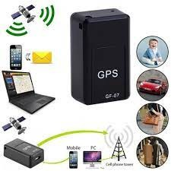

Be sure your kids know whose cars they may ride in and whose they may not. Teach them to move away from any car that pulls up beside them and is driven by a stranger, even if that person looks lost or confused. Develop code words for caregivers other than mom or dad, and remind your kids never to tell anyone the code word. Teach them not to ride with anyone they don’t know or with anyone who doesn’t know the code word. If your kids are old enough to stay home alone, make sure they keep the door locked and never tell anyone who knocks or calls they are home alone.

IoT devices are applied in different fields such as agriculture, medical, industrial, security and communication applications [1]. IoT systems are useful within a system to do deeper automation,

analysis, and integration. IoT contributes to technology by advances in software, hardware and modern tools. It even uses existing and upcoming technology in the fields of sensing, networking and robotics. IoT brings global changes by its advanced elements in the social, economic, and political impact of the users.

The review of literature for child safety and location tracking devices are discussed below. In [2], the parent can send a message to the GSM module, according to the message information the GSM module reply back with particular details of the children. The location can be seen on the Google map. When a particular child is facing an emergency situation, device button should be pressed so that the device captures the image along with the user information to the enrolled mobile numbers. The life of the child can be saved within no time.

In [3], for the children point of view GPS, GPRS and GSM are used to monitor the speed and location tracking purpose. The system is fixed on the bus or car or in any vehicle so that the vehicle is going on routine route or not can be identified by the GPS tracker, the speed of the bus can also be extracted. Now-a-days the digital technology plays a major role for connecting persons via internet. For tracking the children, the android-based solution is provided to parents. Internet is the one that will connect different components through a single device and is connected to server. Parents track their children in real time of the location tracker by GSM and

[4] the microcontroller used is ARM-7 LPC2148. In day-to-day scenario, missing child cases are increasing gradually. Child caring is a major issue. Different types of methods are introduced to find good solutions. There have been many Methods and systems implemented to solve it.

In [5], to solve child caring problem global position system (GPS) based solution with two nodes was proposed. In these two nodes, one node is child node which contains a Bluetooth module and a GPS receiver. The parent node consists of a mobile that supports Bluetooth. The location of the child can be tracked by the GPS technology and can be displayed on the designed.

map in the mobile device, through the Bluetooth connection the distance between the child and parent can be calculated. Children below six years cannot explain in words directly to their parents about the problems, hence a wearable device is developed in [6]. This device procures information such as heart rate, physical body movements and send it to the parents in real time.

In [7], a wearable sensor badge is constructed from (hard) electronic components, which can sense perambulatory activities for context awareness. A wearable sensor jacket is used with latest techniques to form (soft) fabric. Stretch sensors are placed to measure upper limb and body movement. Worn as clothing, the sensors give the required information.[7].

In paper [8], wearable IoT device for the security and shielding of women and girl children was designed. The body temperature and galvanic skin resistance of the body is changed in abnormal conditions. This was used as input information and the alert signal is produced while it crosses the threshold value. This work deals with body temperature and stress, skin resistance and relationship between them. By applying these parameters activity of the person was analysed.

The device [9] an analysis of skin resistance and body temperature was made. Body position is determined by a triple axis accelerometer. After acquiring raw data activity recognition is done and a specialized machine learning algorithm is employed in this process. Real-time data is achieved by sending sensor data to a Cloud Platform. Then the data is analysed using MATLAB.

The jacket consists of different sensors for to detect the activity of the body. In paper [10], there are two modules namely Wi-Fi and audio play back module. The details of the baby can be sent to parents through Wi-Fi module. The audio play back module produces the recorded sound different sensors are accelerometer sensor, cry sensor, temperature sensor gas sensor, flame sensor and PIR sensor. The embedded system consists of microcontroller; accelerometer detects the angular position and movement of the baby.

# References

* + 1. Starner, T Schiele, B and Pentland, A. (1998) ‘Visual contextual awareness in wearable computing’, Second International Symposium on Wearable Computers, Pittsburgh, PA, IEEE Computer Society, pp. 50-57.
    2. AkashMoodbidri, Hamid Shahnasser (Jan 2017) ‘Child safety wearable device’,

International Journal for Research in Applied Science & Engineering Technology, Vol. 6 Issue II, IEEE, pp. 438- 444.

* + 1. AsmitaPawar, PratikshaSagare, TejalSasane, KiranShinde (March– 2017) ‘Smart security solution for women and children safety based on GPS using IOT’, International Journal of Recent Innovation in Engineering and Research, vol. 02, Issue. 03, pp.85-94.
    2. Nitishree, (May-June, 2016) ‘A Review on IOT Based Smart GPS Device for Child and Women Safety’, International Journal of Engineering Research and General Science, Vol.4, Issue. 3, pp. 159- 164.
    3. Kok Sun Wong, Wei Lun Ng, Jin Hui Chong, CheeKyun Ng, AduwatiSali, Nor KamariahNoordin, (15 -17 )December 2009) ‘GPS Based Child Care System using RSSI Technique’, Proceedings of the Malaysia International Conference on Communications. pp. 899- 904.
    4. SeungHee Lee, JaheeSohn, Atsushi Usami, and Masatoshi Hamanaka (2010)‘Development of Wearable Device by Kid’s Friendly Design for Kid’s Safety’ International Federation for Information Processing, IEEE.
    5. Jonny Farringdon, Andrew J. Moore, Nancy Tilbury, James Church & Pieter Biemond .D (october 1999) ‘Wearable Sensor Badge & Sensor Jacket for Context Awareness’, International symposium on Wearable computers, ISWC 99 proceedings of the 3rd IEEE pp107.
    6. Pramod, M UdayBhaskar, Ch V and Shikha, K. (January 2018)‘IOT wearable device for the safety and security of women and girl’ International Journal of Mechanical Engineering and Technology, Vol 9, Issue 1, pp. 83-88.
    7. AnandJatti, MadhviKannan, Alisha,RMVijayalakshmi, P ShresthaSinha (May 20-21, 2016), ‘Design and Development of an IoT based wearable device for the Safety and Security of women and girl children’ IEEE International Conference On Recent Trends In Electronics Information Communication Technology, India, pp. 1108-1112.
    8. Chitra, jewel jose, sandeep, shirinidhishetty, A. (2018) ‘smart safety jacket for smallbaby’

yenepoyainstittite of technology, moodbidr.

# Problem Statement Definition

Child safety and tracking is a major concern as the more number of crimes on children are reported nowadays. With this motivation, a smart IoT device for child safety and tracking is developed to help the parents to locate and monitor their children. The system is developed using LinkIt ONE board programmed in embedded C and interfaced with temperature, heartbeat, touch sensors and also GPS, GSM & digital camera modules. The novelty of the work is that the system automatically alerts the parent/caretaker by sending SMS, when immediate attention is required for the child during emergency. The parameters such as touch, temperature &heartbeat of the child are used for parametric analysis and results are plotted for the same. The above system ensures the safety and tracking of children.

Child tracker helps the parents in continuously monitoring the child's location. They can simply leave their children in school or parks and create a geofence around the particular location. By continuously checking the child's location notifications will be generated if the child crosses the geofence. Notifications will be sent according to the child's location to their parents or caretakers. The entire location data will be stored in the database.

# IDEATION AND PROPOSED SOLUTION

* 1. **Empathy map canvas**

An empathy map is a simple, easy-to-digest visual that captures knowledge about a user's behaviours and attitudes. It is a useful tool to help teams better understand their users. Creating an effective solution requires understanding the true problem and the person who is experiencing it. The exercise of creating the map helps participants consider things from the user's perspective along with his or her goals and challenges.

An empathy map canvas is a more in-depth version of the original empathy map, which helps identify and describe the user's needs and pain points. And this is valuable information for improving the user experience. This information is then used to create personas that help teams visualize users and empathize with them as individuals, rather than just as a vague marketing demographic or account number.

Agile teams in a variety of departments use empathy map canvases to better understand how to meet their customers’ needs. Design teams use them to help understand the various reasons why a user might interact with the product so they can design a user-friendly experience. Sales teams use them to

learn who customers are at an individual level so they can help them invest in a product that suits their needs, rather than leading with a sales pitch that might be off-putting or not appropriately tailored to customers. An empathy map canvas helps brands provide a better experience for users by helping teams understand the perspectives and mindset of their customers. Using a template to create an empathy map canvas reduces the preparation time and standardizes the process so you create empathy map canvases of similar quality.

Good canvases rely on insights from actual users, which help provide an accurate picture of how they feel about their experience with the product. This provides insight into which features are accessed

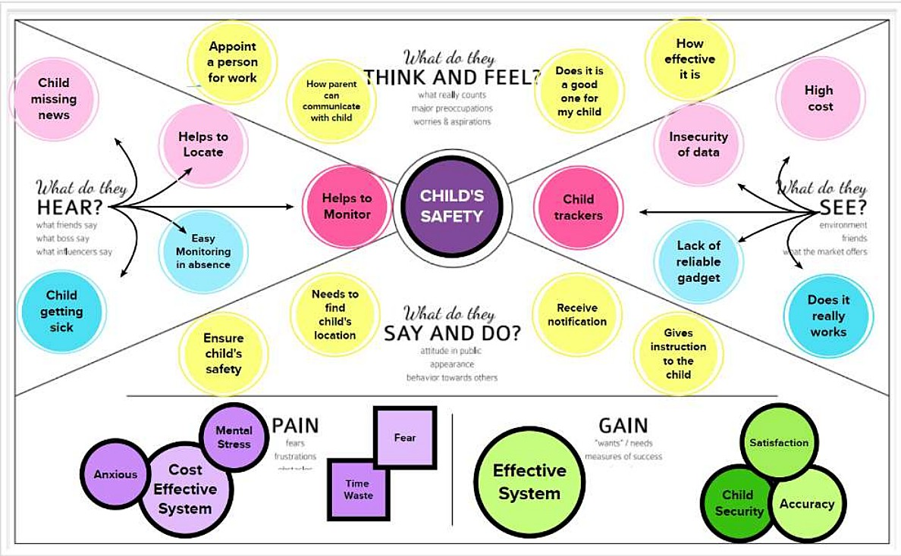

the most often and how they are used. And this knowledge empowers teams to make the improvements that most benefit the user and increase the product’s value.

Revenue-driven design teams use an empathy map canvas to learn what factors most impact a user’s decision to pay for the product or service. This can be particularly useful when teams want to push a new subscription plan and need to understand which features might prompt users to upgrade.

Understanding what users find the most valuable about the product can also help improve

marketing efforts by making it easier to identify why users think it is worth the price.

Empathy maps are divided into segments, which are typically defined by questions that teams work to answer one by one to complete the map. Using mural's template allows you to add color-coded sticky notes to help categorize answers visually. Brainstorm and identify user goals for the product. Consider any fears that might present a hurdle to the sales team, like if they worry about difficult-to- navigate interfaces that slow them down or make their job impossible. Understanding these nuances helps teams identify which features that users prioritize, which allows them to ensure what they offer aligns with users’ needs.

User bases are varied, consisting of many individuals who might have different reasons for using the platform. Relying on a single persona won’t provide an accurate picture of who the average users are or what they need. MURAL allows you to create your own templates and easily duplicate them, which means you can create as many customized personas as you want. The more personas your team creates, the better picture they’ll have of what the user base looks like.

# Ideation And BrainStorming

The device has IoT monitoring and a GSM module that allows the child to be monitored at all times. It also has numerous sensors that are connected to a CPU and are used to detect exact signals such as heart rate, temperature, and other dangers and alert the parents. In the event of a power outage, the wearable serves as a backup. On the device, there is an additional panic button. The purpose of this button is to notify parents and the police of a child's current location whenever they are in a perilous scenario. A GPS module is used to access their present location, and a GSM module assists in transmitting the information via SMS to designated contacts. In this approach, the device tries to provide child safety while remaining unobtrusive.

Our proposed system is based on the Internet of Things-based Smart Child Safety Wearable Device System designed as an efficient and low-cost IoT based system for monitoring infants in real-time. This system plays a key role in providing better care for the lost children until they reconvene with the parents. In this present era, most of the wearable devices today are designed based on the location , activity , temperature, pressure, etc of the child and inform the parents via GPS. Therefore it is intended to use voice call as the way of communication between the parent mobile and child’s wearable device. The system operates on the microcontroller board and the functions of sending and receiving notifications

, calls, voice messages via GPS.

A portable device which will have a pressure switch. As soon as an assailant is about to attack the person or when the person senses any insecurity from a stranger, he/she can then put pressure on the device by squeezing or compressing it. Instantly the pressure sensor senses this pressure and a

conventional SMS, with the victim’s location will be sent to their parents/guardian cell phone numbers stored in the device while purchasing it, followed by a call. If the call is unanswered for a prolonged time, a call will be redirected to the police and the same message will be sent. Additionally, if the person crosses some area which is usually not accessed by the person then a message with the real-time location is sent to the parent/guardian's phone via conventional SMS.

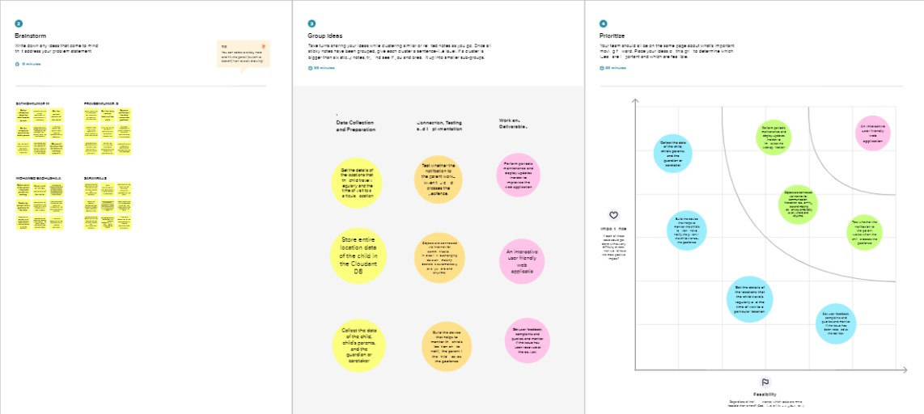

# Proposed Solution

The child safety wearable device is capable of acting as a smart loT device. It provides parents with the real-time location, surrounding temperature, UV radiation index and SOS light along with Distress alarm buzzer for their child's surroundings and the ability to locate their child or alert bystanders in acting to rescue or comfort the child. The smart child safety wearable can be enhanced much more in the future by using highly compact Arduino modules such as the LilyPad, Arduino which can be sewed into fabrics.

Child safety is an unsolved issue. Many of the crimes are left without reported. Each day young children are being assaulted, molested and violated. The street, public transport, public spaces have became the territory of the hunters. Rape is the one of the major crime in India practice against children’s. The crime rate is growing steadily since last few decade. Hence this device makes a step forward and safes victims from such situations. This device is designed in such a way that is easy to use as it works by detecting the abnormal vibrations. Kerala is the state that has the rate 455/1,00000 which is highest of crime reported in the year 2017-2018 says the NCRP (National Crime Records Bureau) and tamilnadu

holds the 3rd position with the rate of 294 /1,00,000 in the NCRP Report of the same year.

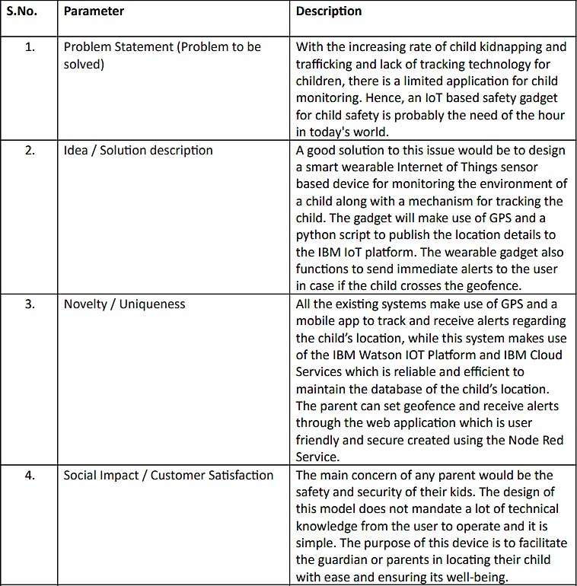

The device when not in use locked so that the unnecessary signals are not sent. For unlocking it, a simple voice command is sufficient when the device is thrown with the force, using force sensor it will start functioning that is it will send the location to the police and distress message to the registered mobile number. The working of the device connected with the jewellery which sends a message to the person when the abnormal force is applied which is like a button, this records a voice message. This device is embedded with the jewellery. But accessing the button in danger and sending alert message through

recording audio are the main drawback.

# Problem Solution Fit

Problem-solution fit is a term used to describe the point validating that the base problem resulting in a business idea really exists and the proposed solution actually solves that problem.The problem- solution fit is when you-

**Validate that the problem exists:** When you validate your problem hypothesis using real-world data and feedback. That is, you gather information from real users to determine whether or not they care about the pain point you’re trying to solve.

**Validate that your solution solves the problem:** When you validate that the target audience appreciates the value your solution delivers to them.

The problem-solution fit precedes the product development and forms the foundation upon which a company is built. It helps you answer the basics startup-related questions before you even start your startup.

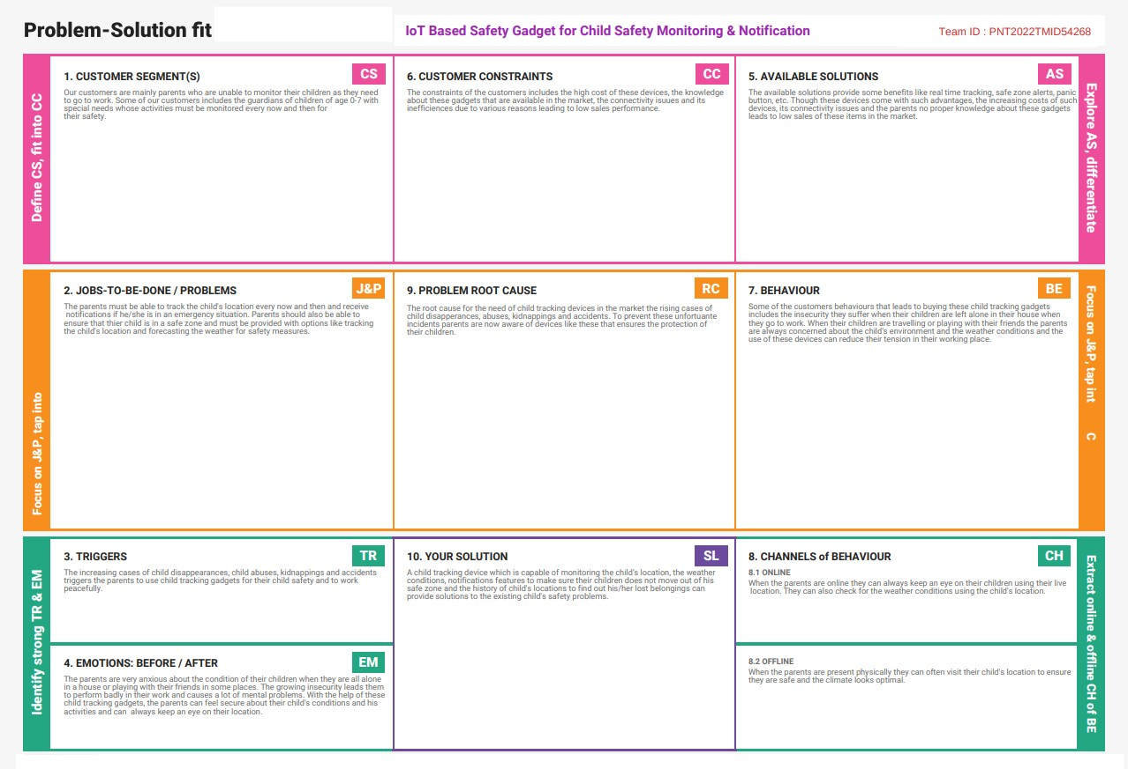

# REQUIREMENT ANALYSIS

* 1. **Functional Requirements**

➤ Notification system

➤ secure personal information(privacy &encryption)

➤ local ranging/positioning(within the domain of the venue)

They must have an early alarm notification to help and to keep the child in range of variable sensitivity and it must have local ranging or positioning that is in the sense that the range of the child should be within the domain of the venue and it must have information privacy securitied information and end-to-end encryption and it also should have child node with child friendly design engage or interest the child and the respective child node with alternative function to be embedded into clothing or locked to child and the absolute outdoor gps style positioning.

# Non Functional Requirements

➤ Reliability

➤ Scalability

They must have reliability and with their respective transparency and the reusability. the main non functional requirements must meet the quality such as the performance with their efficiency of the energy and the properties must meet its scalability features. Nonfunctional Requirements (NFRs) define system attributes such as security, reliability, performance, maintainability, scalability, and usability. They serve as constraints or restrictions on the design of the system across the different backlogs.

# PROJECT DESIGN

* 1. **Data Flow Diagrams**

A Data Flow Diagram (DFD) is a traditional visual representation of the information flows within a system. A neat and clear DFD can depict the right amount of the system requirement graphically. It shows how data enters and leaves the system, what changes the information, and where data is stored.

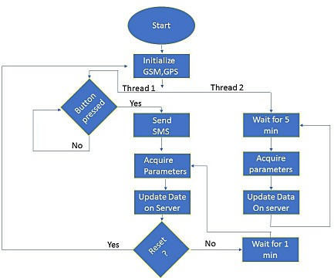

# Solution and Technical Architecture

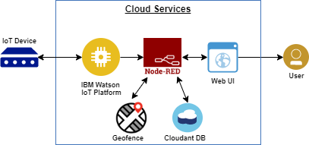

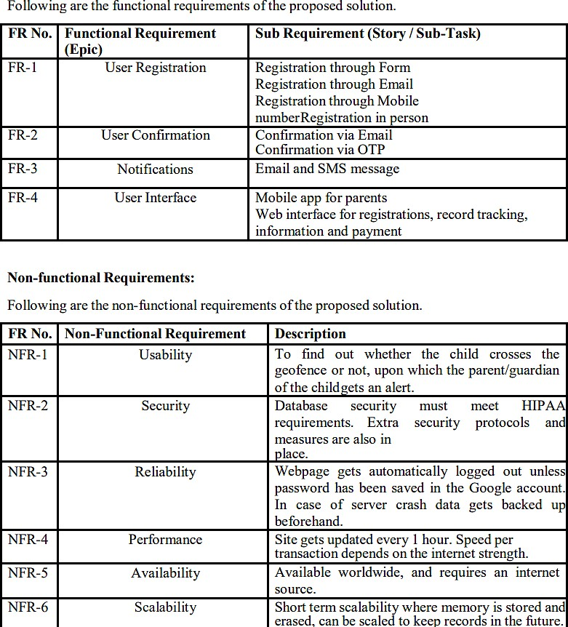

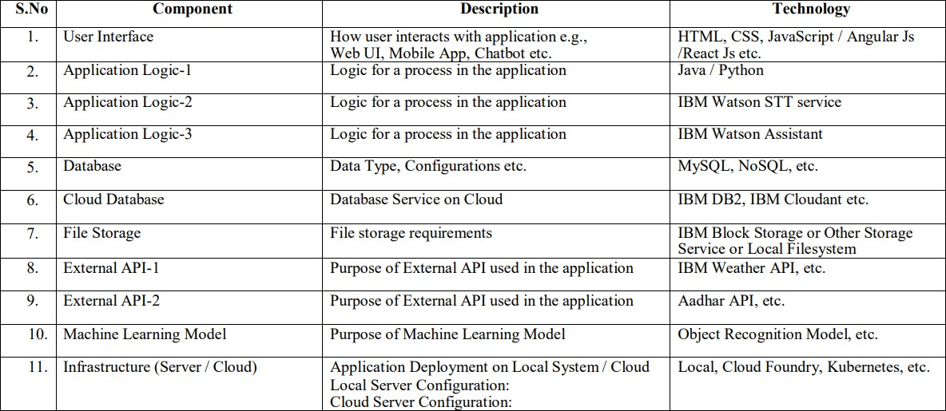

* 1. **User Stories**

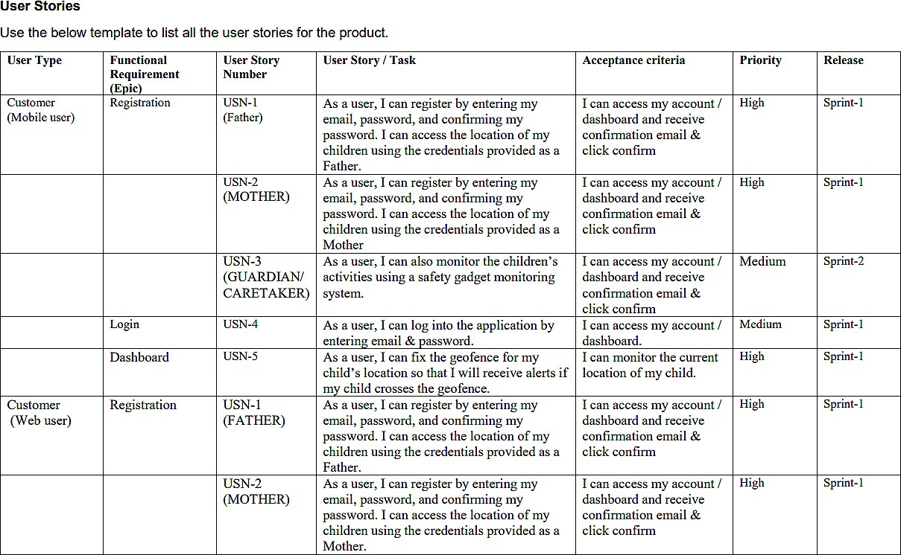

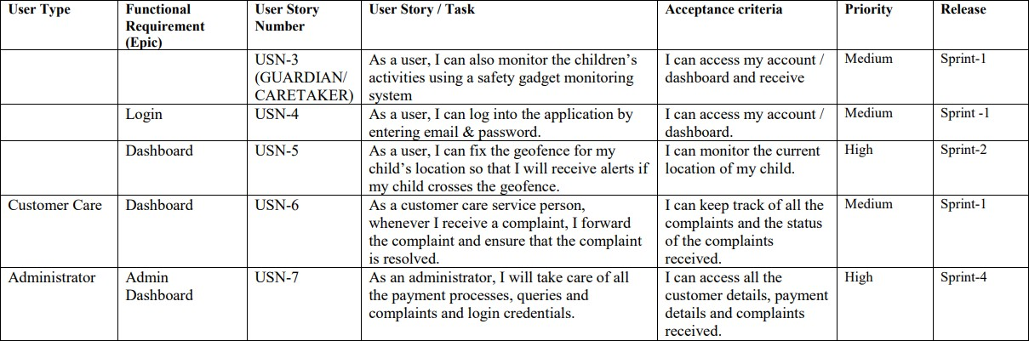

# PROJECT PLANNING AND SCHEDULING

* 1. **Sprint Planning and Estimation**

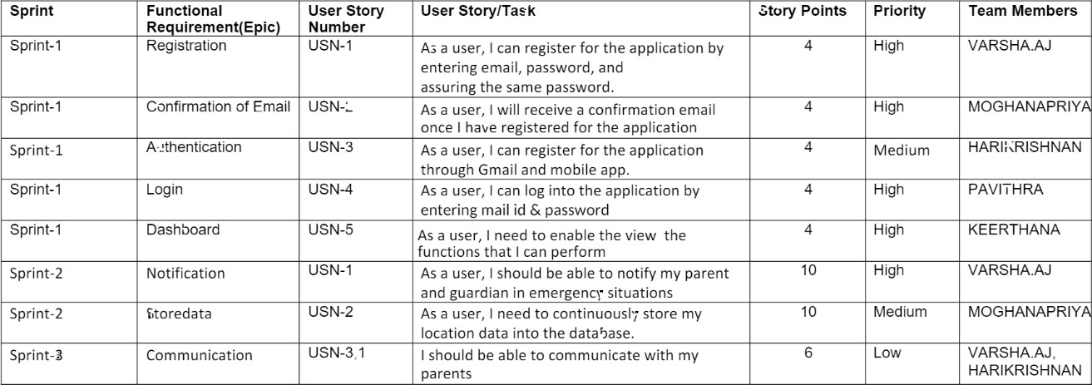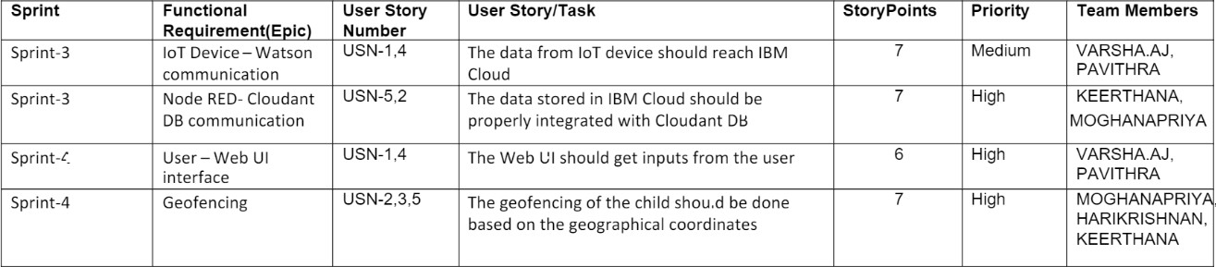

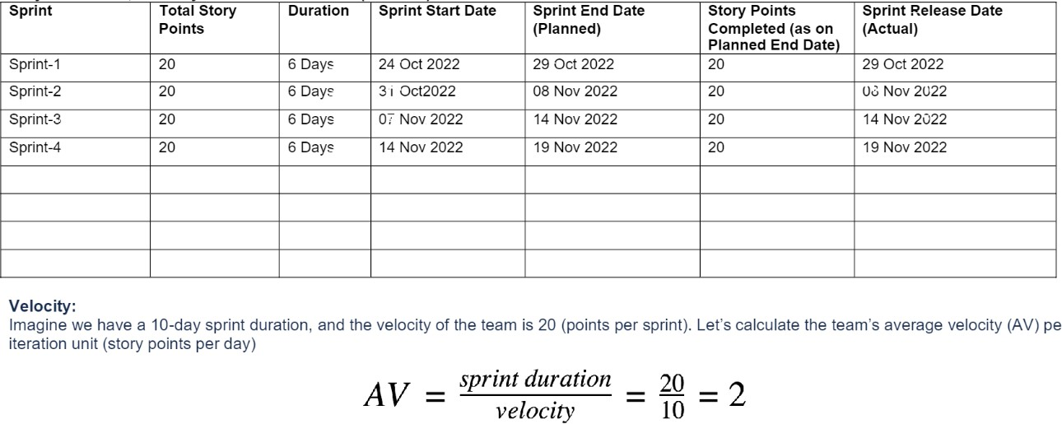

# Sprint Delivery Schedule

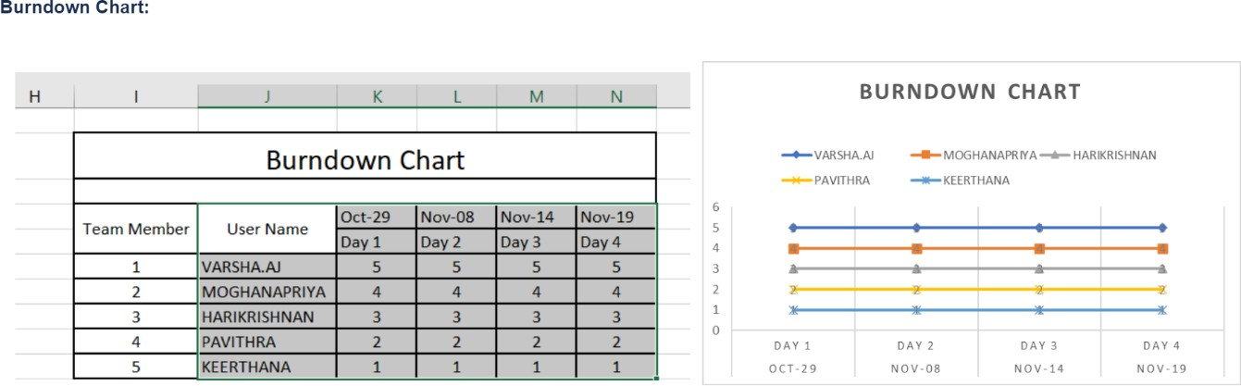

* 1. **Reports From JIRA**

# Sprint 1

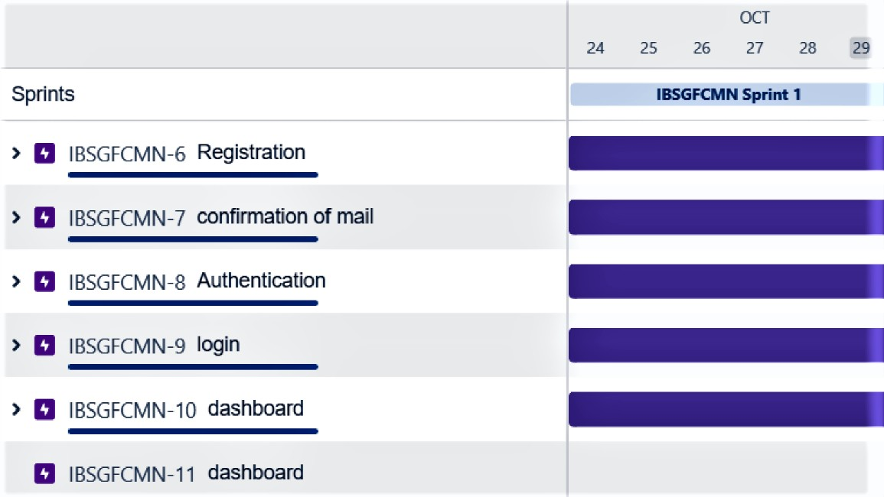

**Sprint 2**

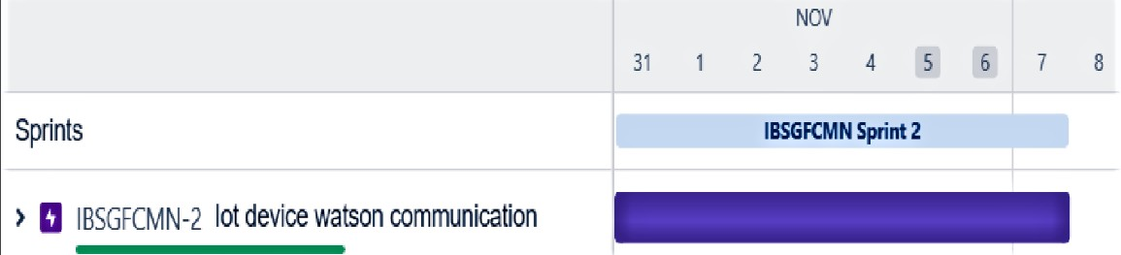

# Sprint 3

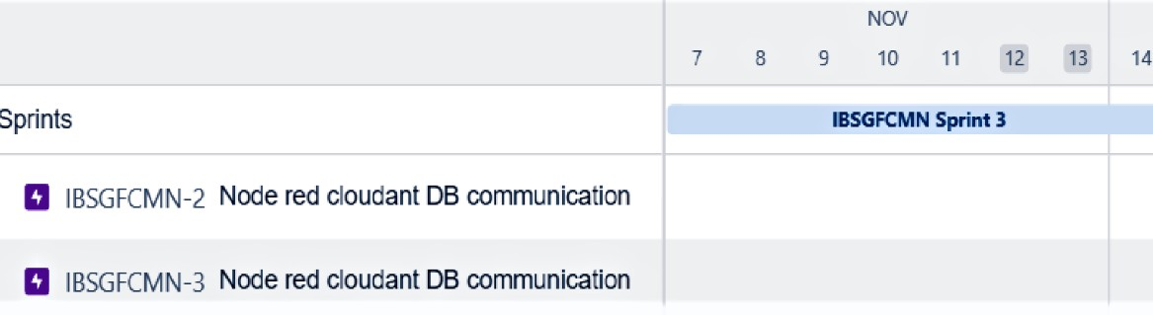

**Sprint 4**

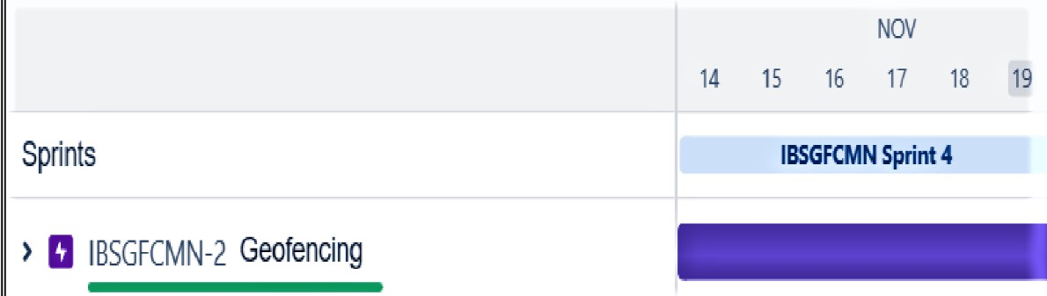

# CODING AND SOLUTIONING

* 1. **Feature 1 Code:**

#include <WiFi.h> #include <PubSubClient.h>

void callback(char* subscribetopic, byte* payload, unsigned int payloadLength);

#define ORG "xd91di"

#define DEVICE_TYPE "nodeajv" #define DEVICE_ID "123"

#define TOKEN "uR1S+yJLg+Sa+)B!zQ" String data3;

char server[] = ORG ".messaging.internetofthings.ibmcloud.com"; char publishTopic[] = "iot-2/evt/Data/fmt/json";

char subscribetopic[] = "iot-2/cmd/test/fmt/String"; char authMethod[] = "use-token-auth";

char token[] = TOKEN;

char clientId[] = "d:" ORG ":" DEVICE_TYPE ":" DEVICE_ID;

WiFiClient wifiClient;

PubSubClient client(server, 1883, callback ,wifiClient); const int trigPin = 5;

const int echoPin = 18;

#define SOUND_SPEED 0.034 long duration;

float distance; void setup() {

Serial.begin(115200); pinMode(trigPin, OUTPUT); pinMode(echoPin, INPUT); wificonnect(); mqttconnect();

}

void loop()

{

digitalWrite(trigPin, LOW); delayMicroseconds(2); digitalWrite(trigPin, HIGH); delayMicroseconds(10); digitalWrite(trigPin, LOW); duration = pulseIn(echoPin, HIGH);

distance = duration * SOUND_SPEED/2; Serial.print("Distance (cm): "); Serial.println(distance);

if(distance<100)

{

Serial.println("ALERT!!"); delay(1000); PublishData(distance); delay(1000);

if (!client.loop()) { mqttconnect();

}

}

delay(1000);

}

void PublishData(float dist) { mqttconnect();

String payload = "{\"Distance\":"; payload += dist;

payload += ",\"ALERT!!\":""\"Distance less than 100cms\""; payload += "}";

Serial.print("Child is not safe: "); Serial.println(payload);

if (client.publish(publishTopic, (char*) payload.c_str())) { Serial.println("Publish ok");

} else {

Serial.println("Publish failed");

}

}

void mqttconnect() {

if (!client.connected()) {

Serial.print("Reconnecting client to "); Serial.println(server);

while (!!!client.connect(clientId, authMethod, token)) { Serial.print(".");

delay(500);

}

initManagedDevice(); Serial.println();

}

}

void wificonnect()

{

Serial.println(); Serial.print("Connecting to "); WiFi.begin("Wokwi-GUEST", "", 6);

while (WiFi.status() != WL_CONNECTED) { delay(500);

Serial.print(".");

}

Serial.println(""); Serial.println("WiFi connected"); Serial.println("IP address: "); Serial.println(WiFi.localIP());

}

void initManagedDevice() {

if (client.subscribe(subscribetopic)) { Serial.println((subscribetopic)); Serial.println("subscribe to cmd OK");

} else {

Serial.println("subscribe to cmd FAILED");

}

}

void callback(char* subscribetopic, byte* payload, unsigned int payloadLength)

{

Serial.print("callback invoked for topic: "); Serial.println(subscribetopic);

for (int i = 0; i < payloadLength; i++) { data3 += (char)payload[i];

}

Serial.println("data: "+ data3); data3="";

}

# Output

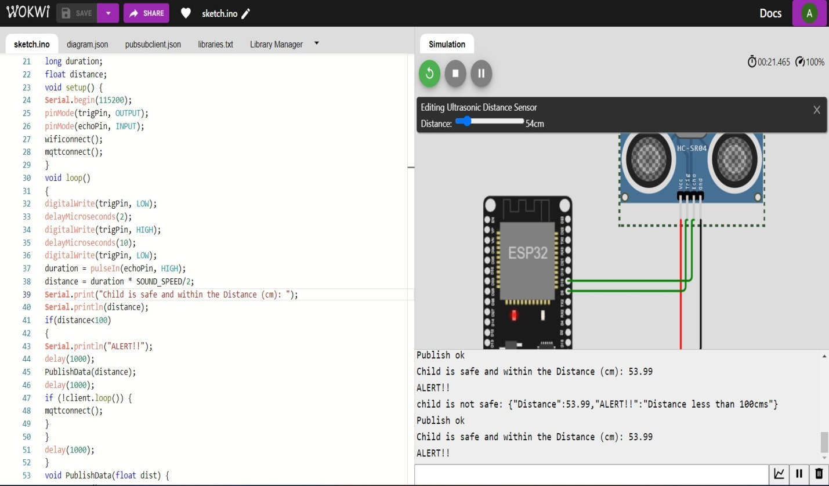

* 1. **Feature 2**

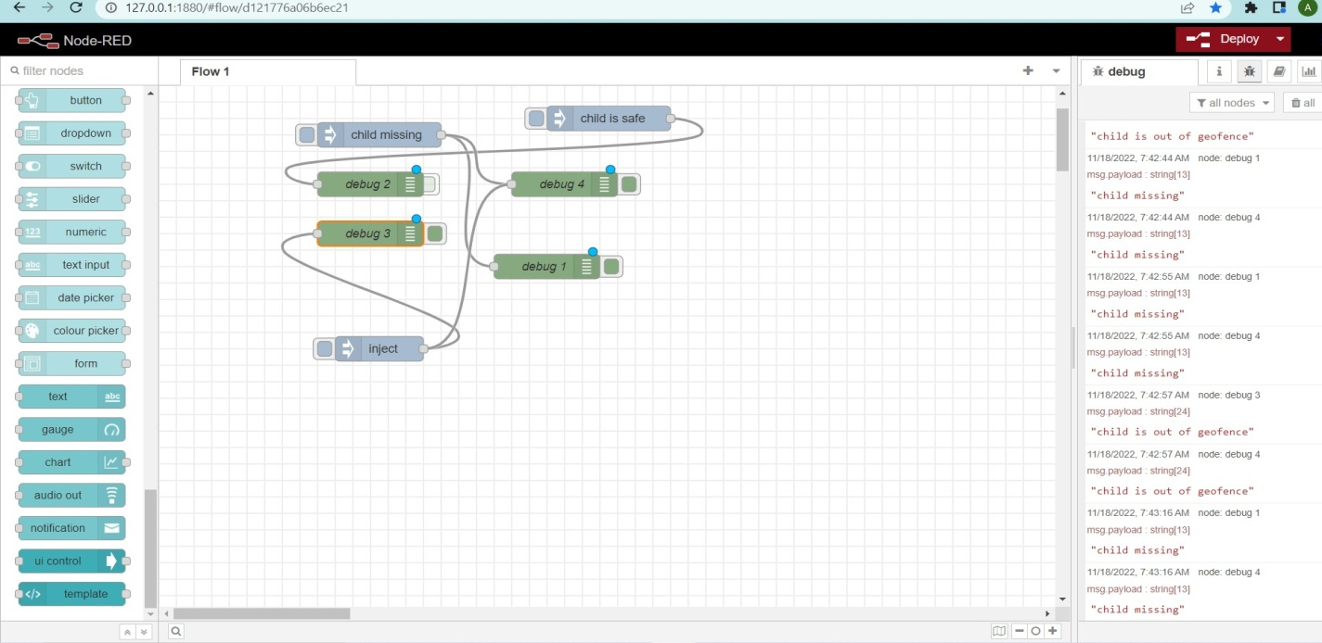

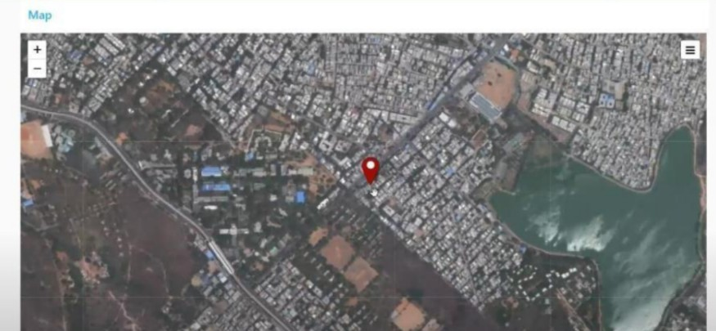

# Database Schema

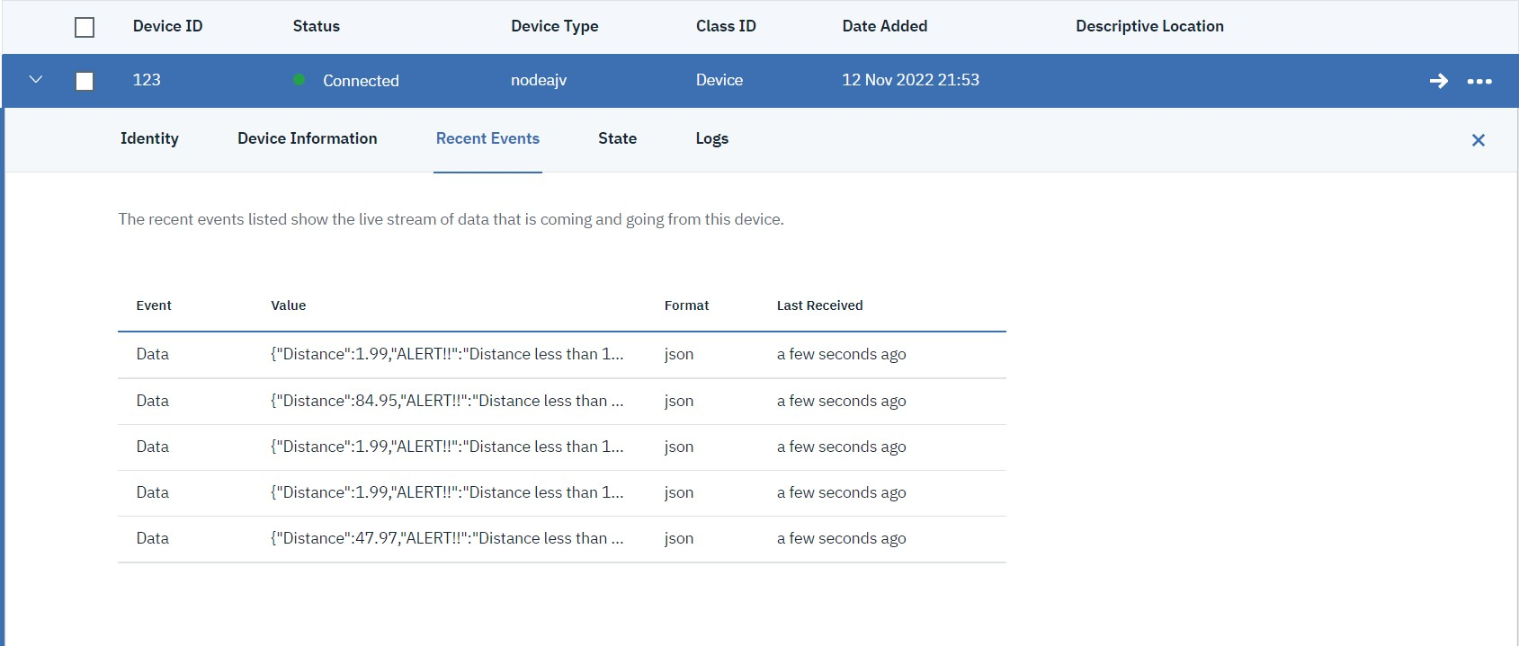

**TESTING**

# Test Cases

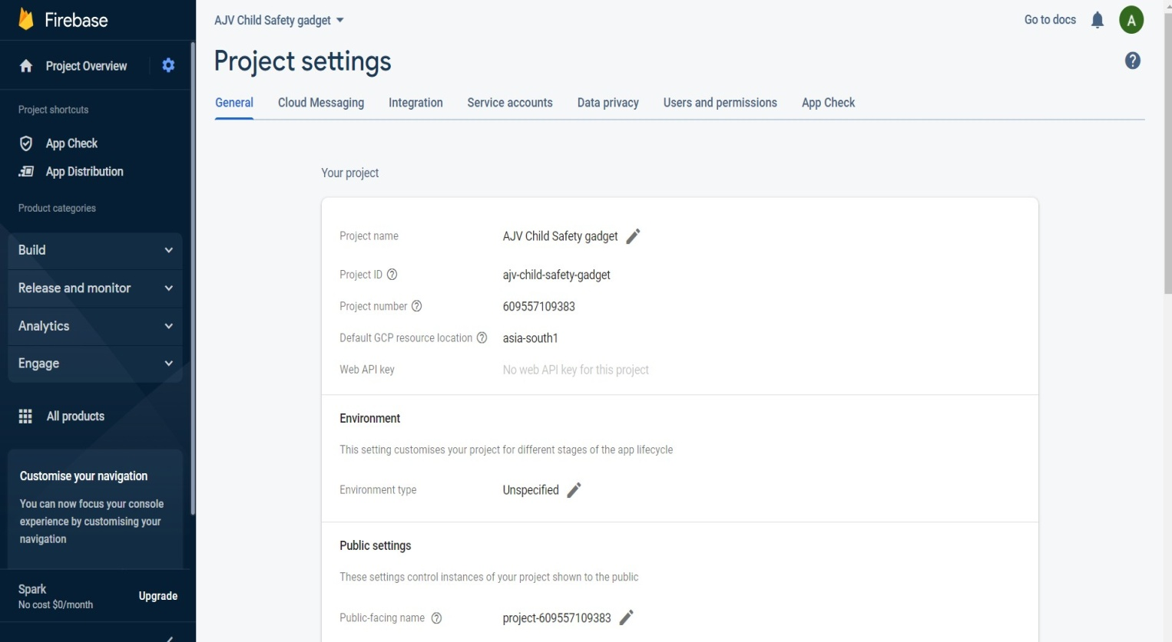

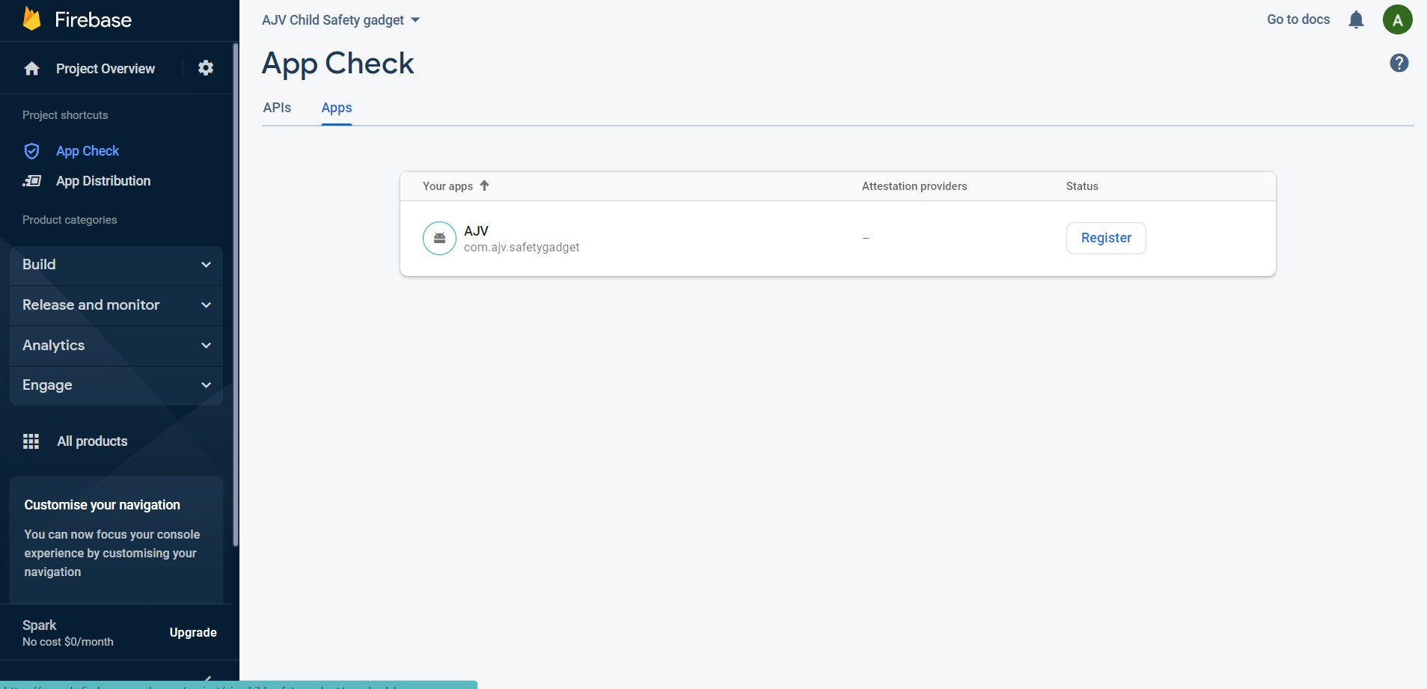

* 1. **User Acceptance Testing**

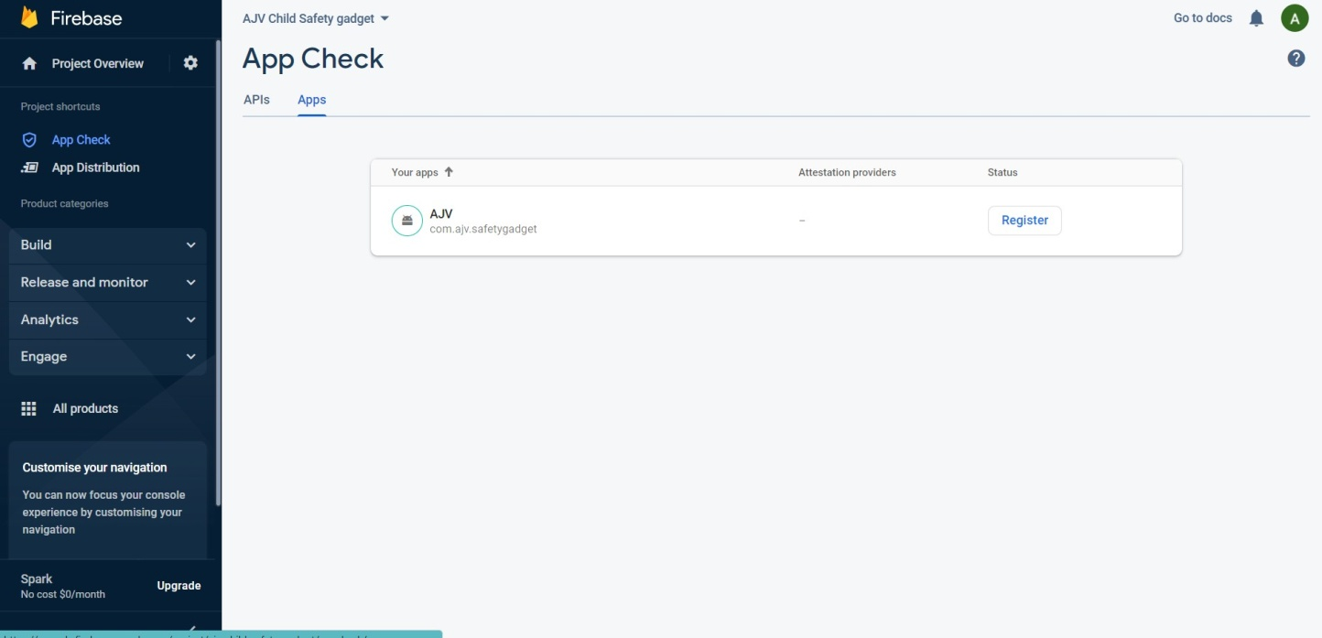

# RESULT

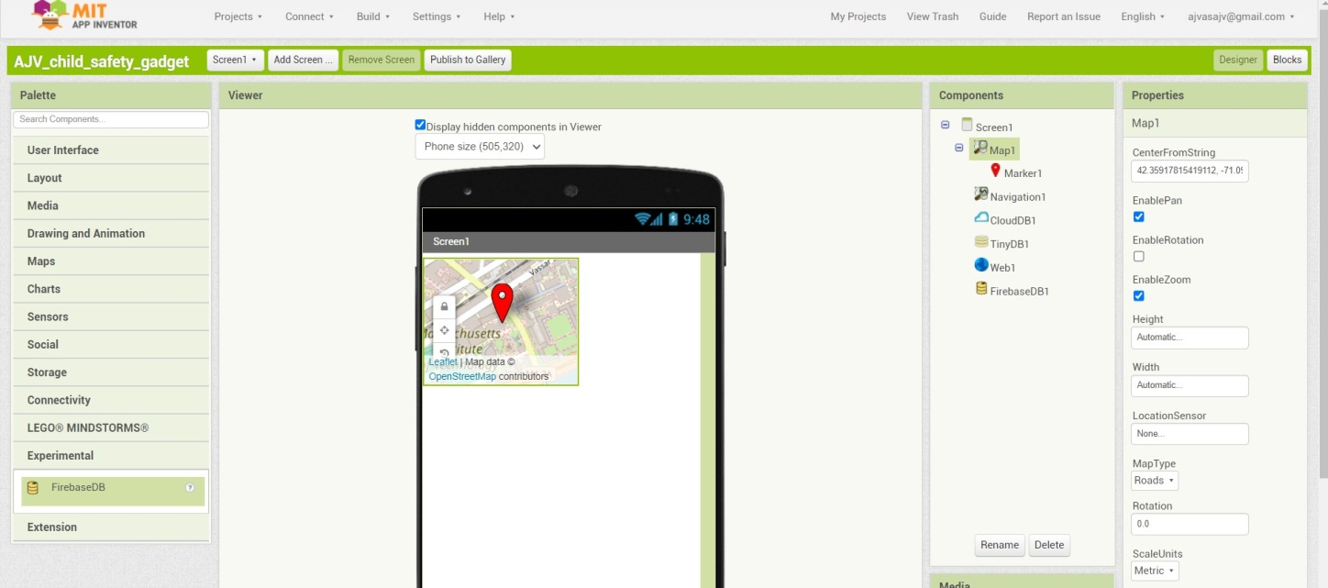

The result was obtained to be child safety locator to detect if the child was missing and we can track the child using our safety monitoring and notification at the right time.

Also the connected device of child's guardian, parents and caretakers will be able to receive the notification since their device was connected to the watson platform.

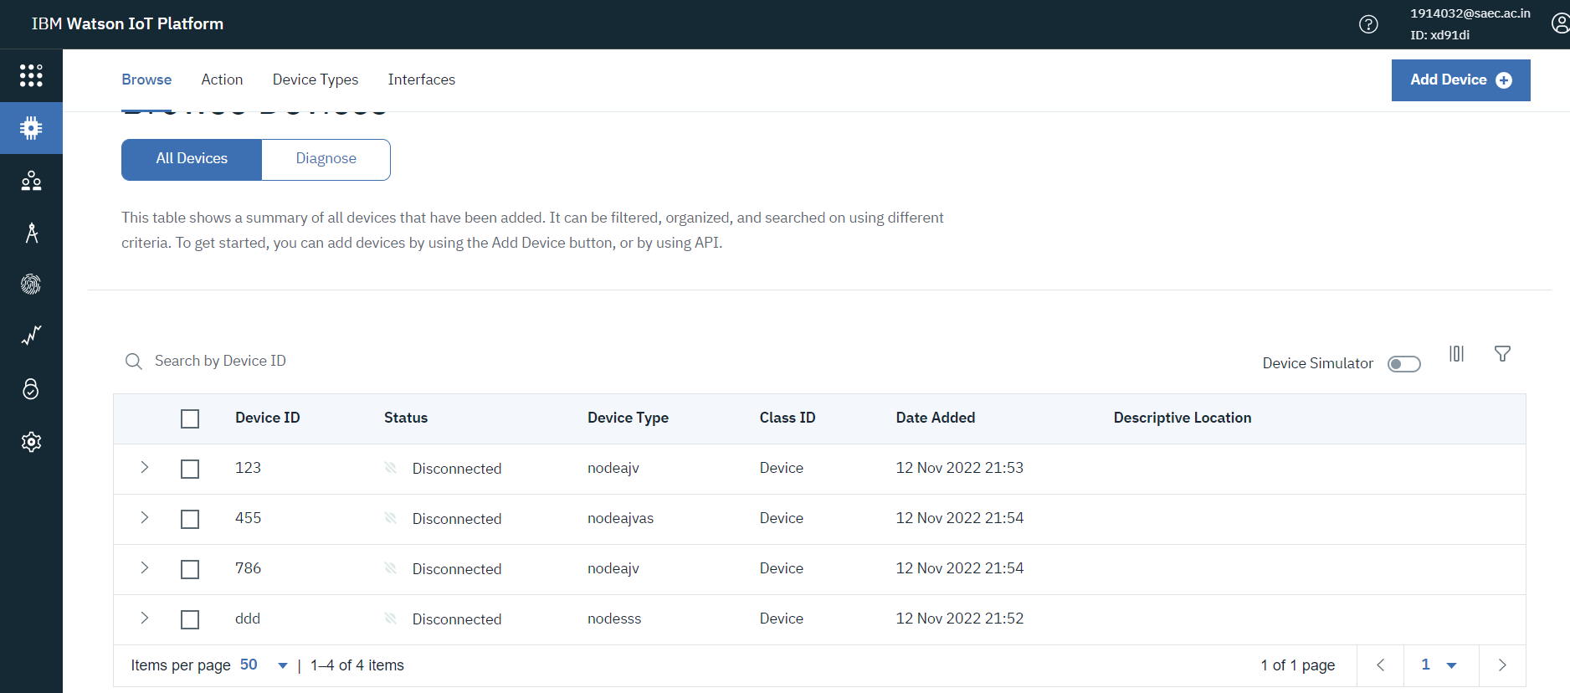

Gps is installed on gadget to track its current location to be tracked on android app and via SMS request send from parent phone to safety gadget.

# 9.1. Performance metrics

Performance measurement is the process of collecting, analyzing and/or reporting information regarding the performance of an individual, group, organization, system or component . Definitions of performance measurement tend to be predicated upon an assumption about why the performance is being measured.

Performance metrics are defined as figures and data representative of an organization's actions, abilities, and overall quality.

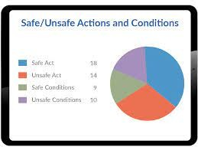

# ADVANTAGES AND DISADVANTAGES

* 1. **Advantages**
     + Easy Availability &Affordability.
     + Tracking Made Easy.
     + Smart watch is Technology in Disguise.
     + Watch over your kids.
     + Track kids when they are away from home and out of your sight.

# Disadvantages

* + - Data security concerns.
    - Technical concerns.
    - Capabilities are limited.
    - Wearable technology is expensive.

# CONCLUSION

Camera Module can be used for surveillance of the child surroundings. This gets a clearer picture of the location or place this wearable can also be incorporated on a camera module . The hardware that can be used would be a adafruit TTL serial camera or any other camera module. Since the major focus of this wearable is the GSM module which is a better alternative than Bluetooth, Wi -Fi or ZigBee due to the short range and connectivity issues.Some camera module supports video streaming. Due to the constraint of trying to use only SMS, only four wire connections are used. The red and black wires will be connected directly to +5V and GND respectively to the Arduino Uno board. The RX pin is used for sending data via arduino Uno and GSM board .The TX pin is utilized for receiving incoming data from the modules. The 10 K resistor divider is used. The camera's serial data pins utilizesa 3.3V logic, and it would be a good idea to divide the 5V down sothat it reaches 2.5V.

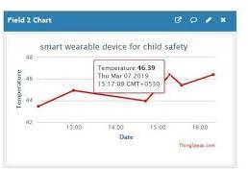

Normally the output from the digital 0 pin is 5V high. Resistors are connected such that camera input never reachesbeyond 3.3V. Two digital pins and a software serial port will be used by Arduino Uno while communicatingwith the camera. An external storage micro board can be used to save the images provisionally asthe camera or the Arduino Uno do not have sufficient onboard storage space to save snapshots .Camera operates on a typical baud rate of 38400 baud. The camera collects information in the same method as the GPS module does.

It will be on standby power saving mode and waits for the keyword ‘snapshot’ or any other word welldefined in the program.This keyword is sent from the user's mobilephone to the GSM kit. This in turn activatesthe camera by the ArduinoUno .Then a snapshotof the surroundings can be taken and the file can be saved temporarily on the external SD (Secure Digital)memory card. After this process, Arduino Uno will access the stored images from the SD storageand relocate it to the GSM module.This in turn is send to the user through SMS text. Android App: An automated bot is required to respond to text message responses from the user. This is the main idea behind the use of Android App.

Response options are predefined and provided to the user at a single click of a button. Specific keywords that are to be sent must be memorized by the user. In addition to it, the automated bot can be pre-programmed to present the user with a set of predefined and specified keyword such as "Location," "Snapshot," "SOS," etc. As a future scope, additional specific keywords could be added. For eg,"Humidity," "Altitude," etc could be added. Android app offers extra edge to the user for understanding easily. Provision of a predefined keyword button for getting Location is the main notion in Android App. This eases the work.

# FUTURE SCOPE

The child safety wearable system acts as a smart device. Child’s surroundings can be located withthehelp of accurate and precise real-time location.Surrounding environment temperature, SOS light alongwith Distress buzzers are provided in this system .This helps in locatingtheir child .Thisalso aids thebystanders to rescue the child. The smart childsafety wearable can be boostedconsiderably in thefuture by using extremely squeezed . Arduino modules like Lily Pad Arduinowhich can beembroidered into fabrics. Also as a future scope, more power eﬃcient model can be created that holds the batteryfor a longer time.

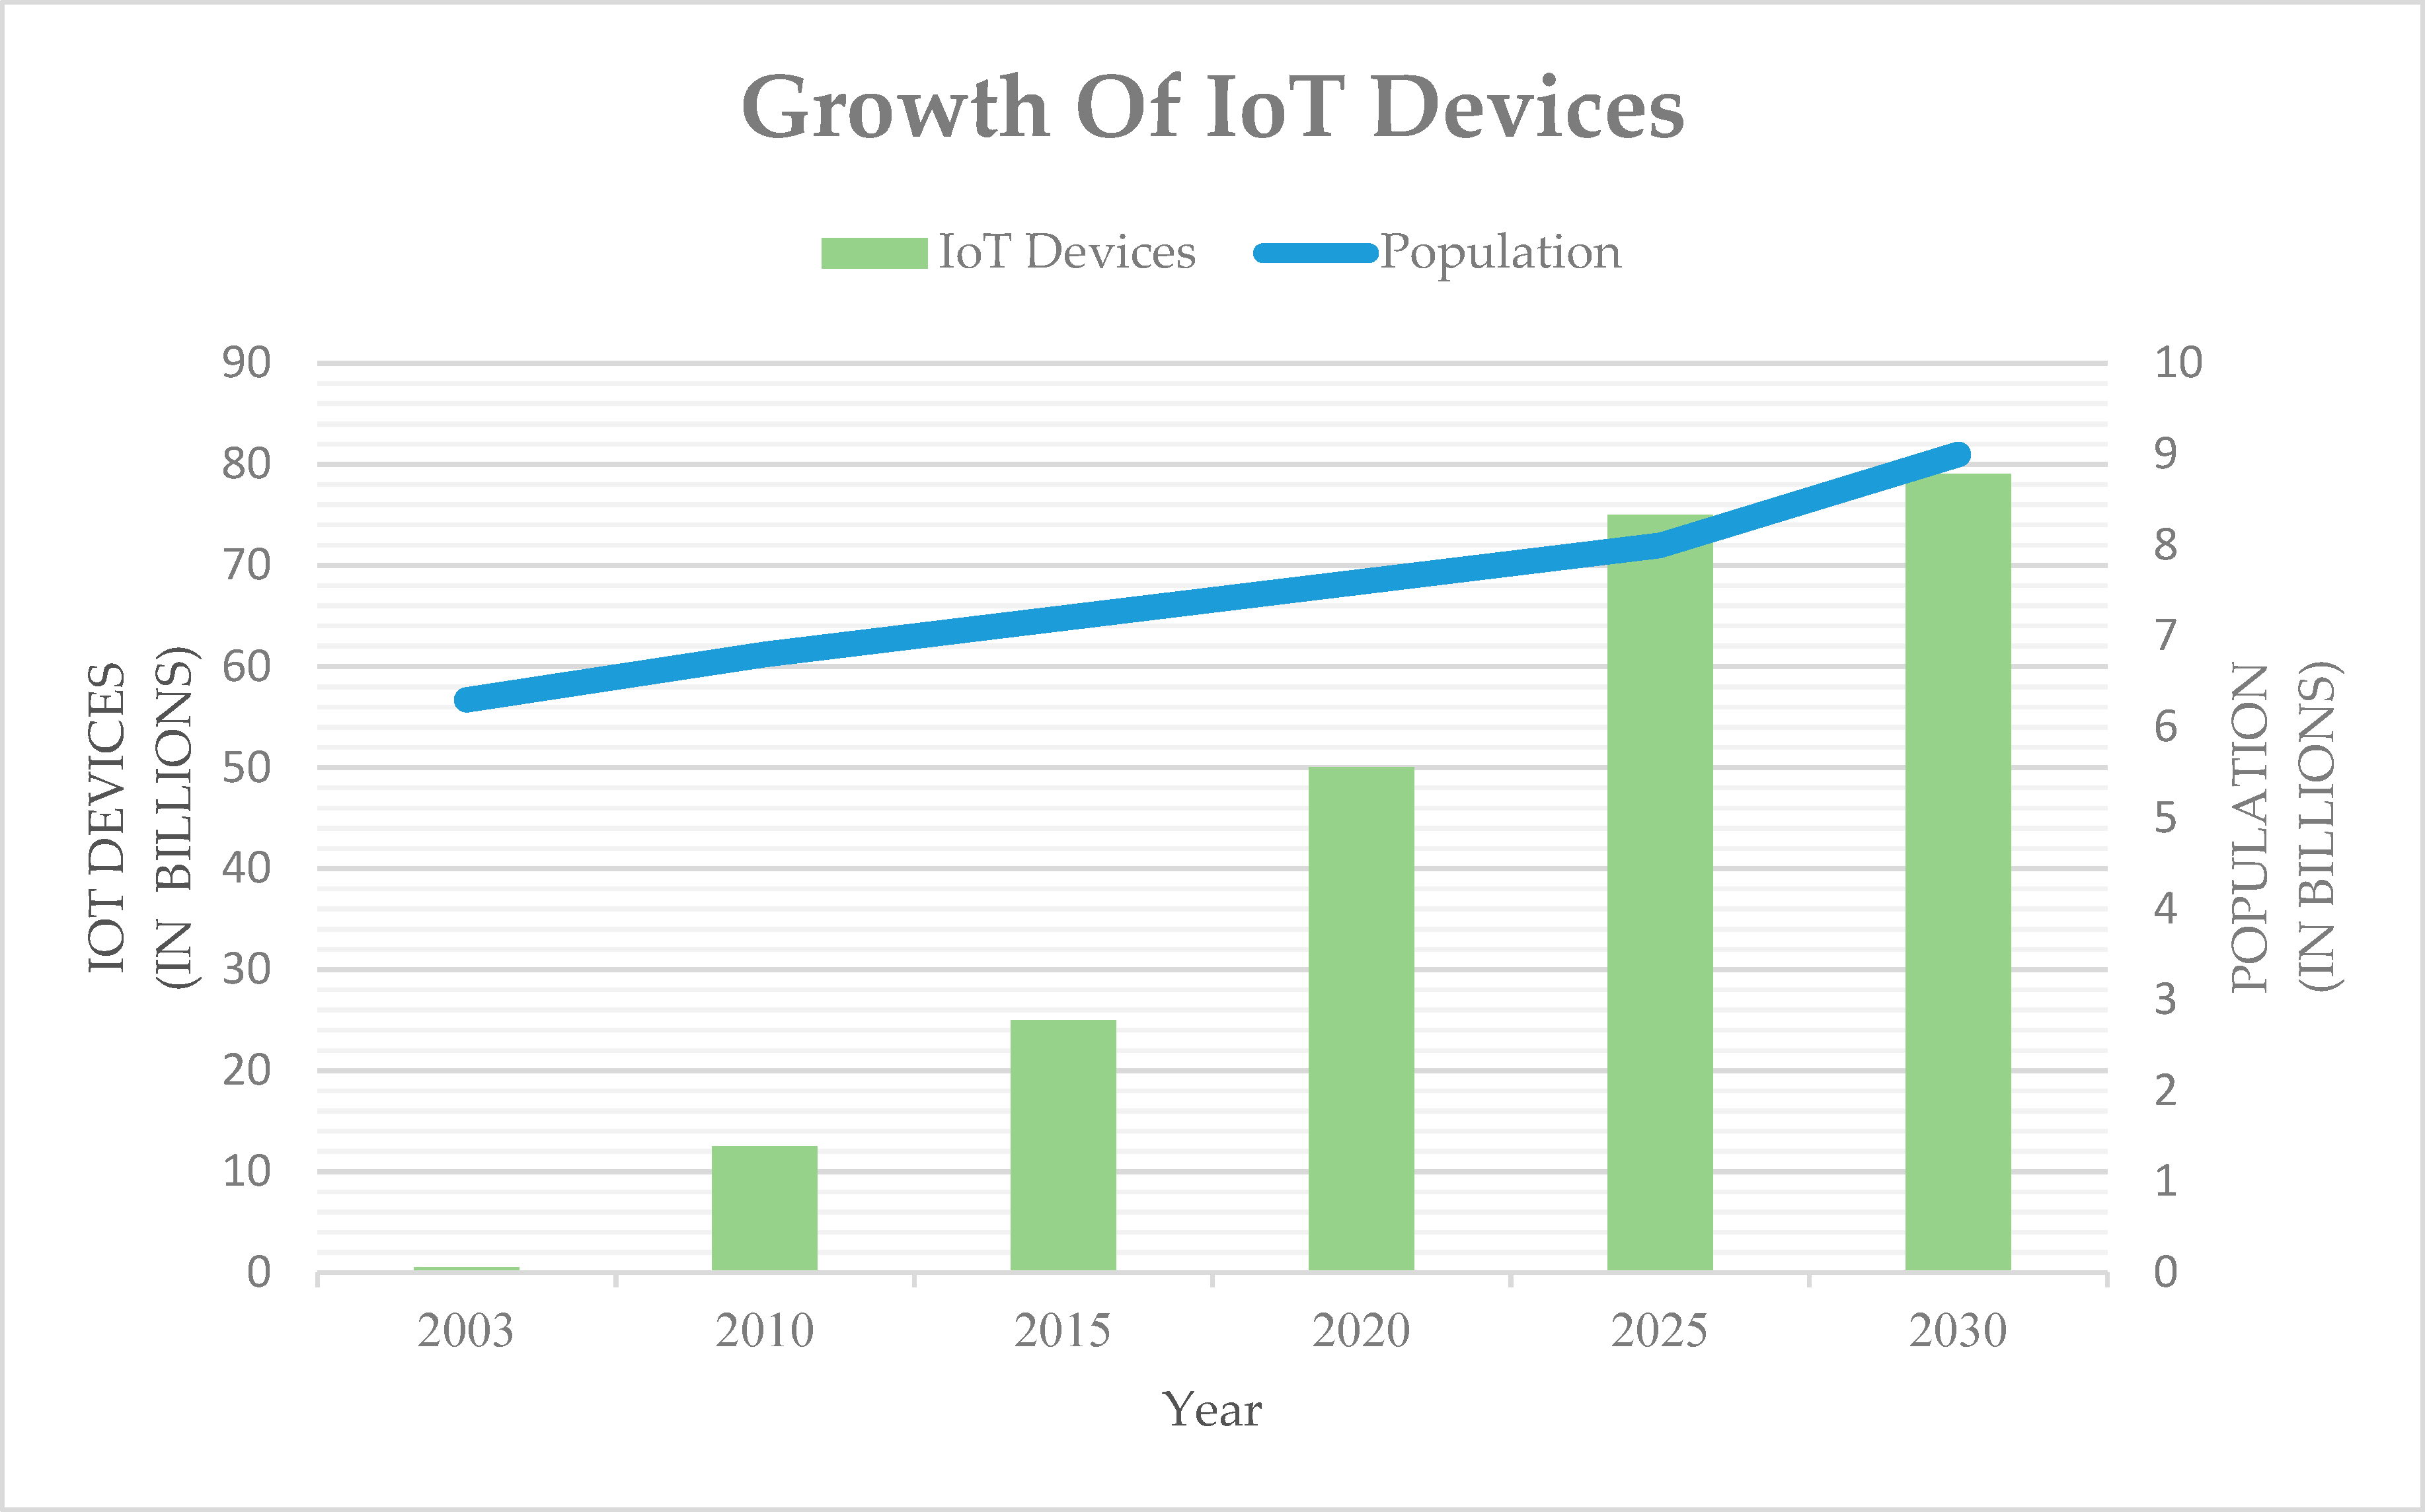

# APPENDIX

* 1. **Source Code code**

#include <WiFi.h>

#include <PubSubClient.h>

void callback(char* subscribetopic, byte* payload, unsigned int payloadLength);

#define ORG "Organization name" #define DEVICE_TYPE "Device type"

#define DEVICE_ID "Organizagion device id" #define TOKEN "Token authentication id" String data3;

char server[] = ORG ".messaging.internetofthings.ibmcloud.com";

char publishTopic[] = "iot-2/evt/Data/fmt/json"; char subscribetopic[] = "iot-2/cmd/test/fmt/String"; char authMethod[] = "use-token-auth";

char token[] = TOKEN;

char clientId[] = "d:" ORG ":" DEVICE_TYPE ":" DEVICE_ID;

WiFiClient wifiClient;

PubSubClient client(server, 1883, callback ,wifiClient); const int trigPin = 5;

const int echoPin = 18;

#define SOUND_SPEED 0.034 long duration;

float distance; void setup() {

Serial.begin(115200); pinMode(trigPin, OUTPUT); pinMode(echoPin, INPUT); wificonnect(); mqttconnect();

}

void loop()

{

digitalWrite(trigPin, LOW); delayMicroseconds(2); digitalWrite(trigPin, HIGH); delayMicroseconds(10); digitalWrite(trigPin, LOW); duration = pulseIn(echoPin, HIGH);

distance = duration * SOUND_SPEED/2; Serial.print("Distance (cm): "); Serial.println(distance);

if(distance<100)

{

Serial.println("ALERT!!"); delay(1000); PublishData(distance); delay(1000);

if (!client.loop()) { mqttconnect();

}

}

delay(1000);

}

void PublishData(float dist) { mqttconnect();

String payload = "{\"Distance\":"; payload += dist;

payload += ",\"ALERT!!\":""\"Distance less than 100cms\""; payload += "}";

Serial.print("Child is not safe: "); Serial.println(payload);

if (client.publish(publishTopic, (char*) payload.c_str())) { Serial.println("Publish ok");

} else {

Serial.println("Publish failed");

}

}

void mqttconnect() {

if (!client.connected()) { Serial.print("Reconnecting client to "); Serial.println(server);

while (!!!client.connect(clientId, authMethod, token)) { Serial.print(".");

delay(500);

}

initManagedDevice(); Serial.println();

}

}

void wificonnect()

{

Serial.println(); Serial.print("Connecting to "); WiFi.begin("Wokwi-GUEST", "", 6);

while (WiFi.status() != WL_CONNECTED) { delay(500);

Serial.print(".");

}

Serial.println(""); Serial.println("WiFi connected"); Serial.println("IP address: "); Serial.println(WiFi.localIP());

}

void initManagedDevice() {

if (client.subscribe(subscribetopic)) { Serial.println((subscribetopic)); Serial.println("subscribe to cmd OK");

} else {

Serial.println("subscribe to cmd FAILED");

}

}

void callback(char* subscribetopic, byte* payload, unsigned int payloadLength)

{

Serial.print("callback invoked for topic: "); Serial.println(subscribetopic);

for (int i = 0; i < payloadLength; i++) {

data3 += (char)payload[i];

}

Serial.println("data: "+ data3); data3="";

}

# GITHUB AND PROJECT DEMO LINK

Github link**:**[**https://github.com/IBM-EPBL/IBM-Project-42215-1660656339**](https://github.com/IBM-EPBL/IBM-Project-42215-1660656339)Project Demo link:<https://photos.app.goo.gl/s2TvZuGhNrxg8fZf8>